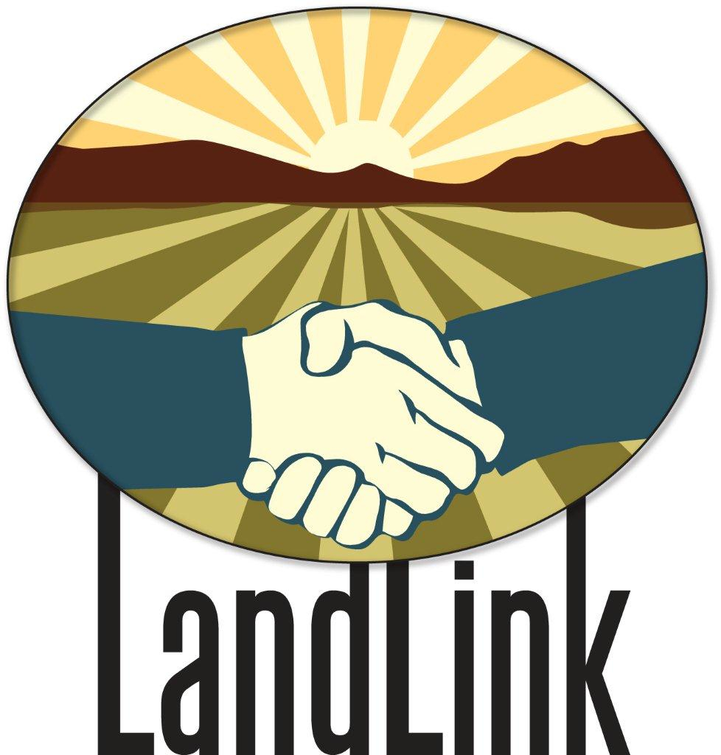
Central New Mexico LandLink
Sample Memorandum of Understanding (MOU)

An MOU is a document that describes an agreement between two parties and sets out the parties’ common goals and courses of action. MOUs are used by parties who want to enter into an agreement together, but do not want the rigid formalities of a traditional lease agreement.

____________________________________________________________
Please note: This document is provided for informational purposes only, and in no way represents legal advice or recommendations of any sort. The Central New Mexico LandLink assumes no responsibility for this information or its use by any other party. If you have any questions, we encourage you to seek legal counsel.

Sample
Memorandum of Understanding (MOU)

between

________________________________________________________________________

and

________________________________________________________________________

This is an agreement between _________________________________, hereinafter called “the Landholder,” and _________________________________, hereinafter called “the Tenant.” They shall be hereinafter jointly referred to as “the Parties.”

Purpose

The purpose of this MOU is to clearly identify the roles and responsibilities of each party as they relate to the use of the Landholder’s property (described below), by the Tenant, for agricultural purposes.

Property Description

This MOU pertains to the following property (use legal description):
________________________________________________________________________________________________________________________________________________

Commitments

The Landholder shall undertake the following activities:

- Insert information about landholder’s right to enter the property for specific purposes.

- Insert information about property maintenance and improvements.

- Insert information about repairs.

- Insert information about rent payment (how and where to receive, what to do when rent is late, etc.)

The Tenant shall undertake the following activities:

- Insert information about farming practices.

- Insert information about use of equipment, property, restrooms.

- Insert information about use of water for irrigation.

- Insert information about financial obligations (payment, crop-share, etc.).

- Insert information about reimbursement for damages.

- Insert information about necessary insurance policies.

You may include or remove any stipulations you see fit. As listed above, details you may want to consider include: property improvements, repairs, maintenance, damages, property access, insurance, desired farming practices, financial obligations (payment, crop-share), use of equipment, use of irrigation water, etc.

Implementation, Amendment, and Termination

It is mutually understood and agreed by and between the Parties that:

- This MOU is effective upon signature by the final approving party indicated below.

- This MOU will expire on ____________________________, unless terminated, extended, or renewed in writing. The terms of such extension or renewal will be in writing and require the signature of both parties.

- This MOU may only be amended through written agreement of both parties. All notices, consents, and approvals required by this MOU must be in writing. Either party has the right, by giving written notice to the other party, to change the address at which its notices are to be received. Notices shall be delivered as follows:

Landholder: Tenant:
___________________________ ___________________________
___________________________ ___________________________
___________________________ ___________________________
___________________________ ___________________________

- This MOU may be terminated prior to the expiration date by providing _____ calendar days written notice of termination to the other party.

You may insert any other information you feel is necessary in this section.

Signatures

The Parties hereto have executed this MOU on the dates shown below.

__________________________________________ ________________________
Signature Date

__________________________________________ ________________________
Signature Date

